Workbook: Go Math - Middle School Grade 6
published by HMH (Houghton MIfflin Harcourt)

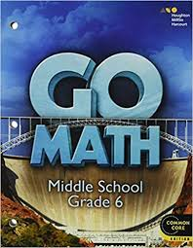

Supplies / Tools
- Notebook (no rings)
- Folder to gather and carry worksheets, quizzes and tests of current work
- Binder to keep all quizzes and tests from completed chapters in order of date.
- Ruler - inches and centimeters on the same ruler
- Protractor
- Loose-leaf paper - buy a pack, keep it at home and keep refilling a small supply in your folder.
- Pencils, erasers, sharpeners, scissors
- Hand-sanitizer, disinfectant wipes

