CH 5 ENERGY ASSESSMENT

Matching

Match each example to the type of energy resource it is.
a. | Nonrenewable energy source
b. | Renewable energy source

____ 1. water

____ 2. sunlight

____ 3. coal

____ 4. wind

____ 5. petroleum

____ 6. natural gas

____ 7. biomass

____ 8. uranium

____ 9. oil

____ 10. geothermal energy

Short Answer

1. How could you increase the kinetic energy of a wagon without increasing its mass?

2. Name two ways you could increase the potential energy of a bucket of water sitting on a bench.

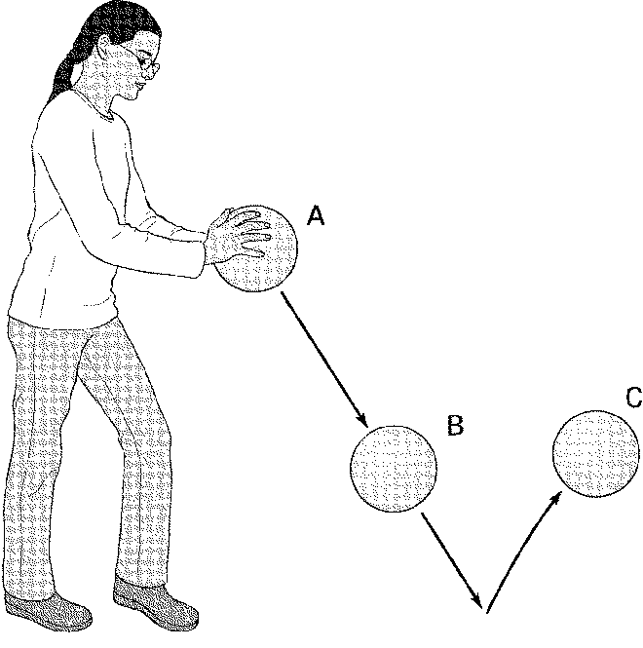

3. A rubber ball is dropped and bounces back up. What kind of energy does the ball have at points A, B, and C?

4. When the ball bounces back up, it doesn’t quite reach the height of the hand. Is energy lost? Explain.

5. Trace the flow of energy in a hydroelectric plant.

6. Explain how energy from fossil fuels gets to your car, starting with the Sun.

7. Why do we need to find an alternative to fossil fuels?

8. When coasting while roller skating, you eventually stop. Why?

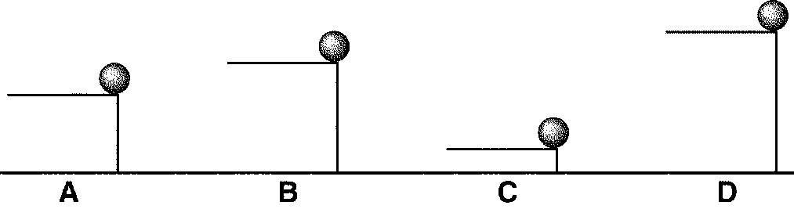

9. Which ball has the greatest potential energy?

10. Which ball has the least potential energy?

11. A ball has 100 J of potential energy when it is on a shelf. Explain what happens to the potential energy and the kinetic energy as the ball falls, and find the amount of kinetic energy the ball has at the instant it hits the floor.

12. Explain the changes in energy when a child slides down a sliding board.

13. How does the child's ride on the slide change if the slide is lubricated with water to make it slippery?

14. What kind of energy is stored in food?

15. A dump truck, a sports car, and a bicycle are traveling at the same velocity. Compare their kinetic energies

